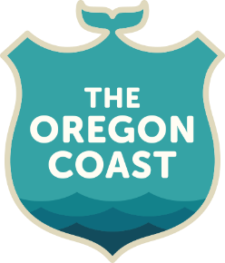
SB 1525: Support the Blue Economy

- Senate Bill 1525, the Blue Economy Task Force Bill, creates a task force to explore, define and create a roadmap for developing the blue economy in Oregon.

- SB 1525 will provide the science and information Oregon needs to support a healthy ocean and vibrant coastal economies. Investing in the Blue Economy will strengthen coastal communities and their economies. It also will help empower our region’s communities to be major contributors in the statewide economic prosperity we seek.

- We are working with multiple partners to develop certain sectors of Oregon’s Blue Economy through the following efforts:

  - Working to create coastal infrastructure to keep more Oregon seafood local. Real economic value is developed through the supply chain, where dollars are multiplied and jobs are created.
- Pursuing 100 Percent Fish initiatives to utilize fish waste from food processing for creating additional value-added food and non-food products. This will build new kinds of products produced in Oregon, such as pharmaceuticals, nutraceuticals, fish leather, collagens, scientific and medical products and much more.
- Developing and promoting top-notch visitor experience on the Oregon Coast.

- But the Blue Economy can be even more in Oregon. It is time to explore these opportunities. SB 1593 will create a taskforce that includes a variety of business interests, including tourism, fisheries, blue economy business investors and many more to define what this means and study what other states and nations are doing successfully regarding the blue economy.
- The group will identify existing initiatives to spot gaps and overlaps, and create strategies to address them. This work should lead to a Blue Economy Roadmap to chart Oregon’s course in this endeavor.
- With the invigorated focus Oregon is taking regarding economic development, this is an incredible way to include Oregon’s coastal communities in the state’s future economic prosperity.

